HALO-(AC)³ – 2022/03/dd – HALO research flight #YY
Objectives:
One sentence on the major objectives
__________________________________________________________________________________
HALO Crew
Mission PI | Xxxxx xxxxx
HAMP | Xxxxx xxxxx
WALES | Xxxxx xxxxx
SMART/VELOX | Xxxxx xxxxx
specMACS | Xxxxx xxxxx
Dropsondes | Xxxxx xxxxx
Optional | Xxxxx xxxxx
Pilots | Xxxxx xxxxx
Engineer | Xxxxx_xxxxx
Mission PI HALO:
Xxxxxx Xxxxxx

HALO
Take off | xx:xx UTC
Touch down | xx:xx UTC
Flight times:

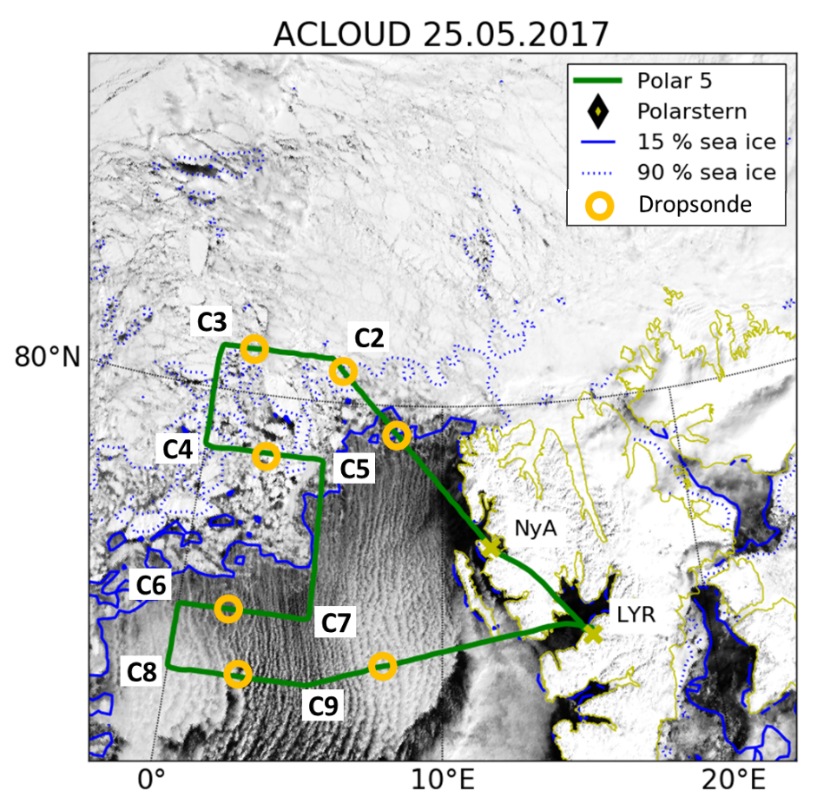
Fig. 1: MODIS RGB composite satellite image and sea ice fraction observed by the Advanced Microwave Scanning Radiometer (AMSR2) by the University of Bremen (Spreen et al., 2008).
__________________________________________________________________________________
Weather situation as observed during the flight (compare to forecast):
….. how was the forecast…. And how the situation was observed during the flight

__________________________________________________________________________________
Overview:
… general remarks on the strategy of the flight
… how things and flight pattern worked out
… major notes: What special or remarkable situations/surprises appeared during the flight. Problems
… flight pattern

__________________________________________________________________________________
Instrument Status:
HALO
BAHAMAS
BACARDI
HAMP Radar
HAMP Radiometer
WALES
SMART
VELOX
specMACS
Dropsondes
Table 1: Instrument status as reported after the flight for all instruments on HALO.
Comments: for instruments that are not green, what did not work...

__________________________________________________________________________________
Detailed Flight Logs:
… fill with flight log notes. Best always give a time
maneuvers
cloud conditions in particular areas/legs
sea ice conditions in particular areas/legs
precipitation
etc…

__________________________________________________________________________________
Quicklooks:

