MOSAiC-ACA Flight #xx – Polar 5 – 2020/03/xx
Objectives:
One sentences on the major objectives
__________________________________________________________________________________
Polar 5 Crew
Mission PI | Xxxxx xxxxx
Basis Data Acq. | Xxxxx xxxxx
SMART/ Eagle/Hawk | Xxxxx xxxxx
MiRAC / AMALi | Xxxxx xxxxx
Microphysics | Xxxxx xxxxx
Optional seat | Xxxxx xxxxx
Mission PI P5:
André Ehrlich

Polar 5
Take off | xx:xx UTC
Touch down | xx:xx UTC
Flight times:

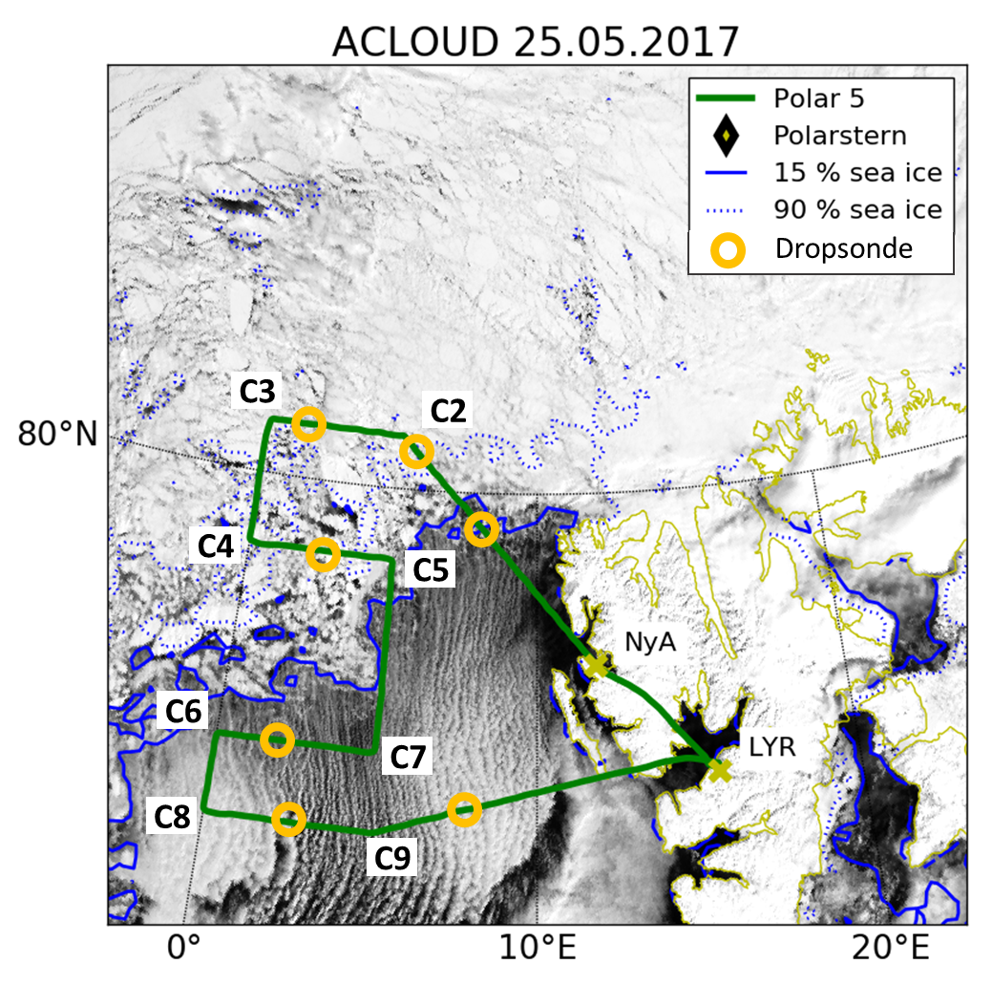
Fig. S5.1: MODIS RGB composite satellite image and sea ice fraction observed by the Advanced Microwave Scanning Radiometer (AMSR2) by the University of Bremen (Spreen et al., 2008).
__________________________________________________________________________________
Weather situation as observed during the flight (compare to forecast):
….. how was the forecast…. And how the situation was observed during the flight
__________________________________________________________________________________
Overview:
… general remarks on the strategy of the flight
… how things and flight pattern worked out
… major notes: What special or remarkable situations/surprises appeared during the flight. Problems
… flight pattern
__________________________________________________________________________________
Instrument Status:
Polar 5
Basis data acquisition | INS not aligned
Nose Boom
MiRAC-A
MiRAC-P
AMALi
SMART
Eagle/Hawk
Sun Photometer
Polar Nephelometer
2D-S
CAPS
PIP
Drop Sondes | None launched
Table S5.1: Instrument status as reported after the flight for all instruments on Polar 5.
Comments: …. What did not work….
__________________________________________________________________________________
Detailed Flight Logs:
… fill with flight log notes. Best always give a time
maneuvers
cloud conditions in particular areas/legs
sea ice conditions in particular areas/legs
precipitation
etc…

__________________________________________________________________________________
Quicklooks:

